Pizza Sales Queries

KPI’s –

1. Total Revenue-

select sum(total_price) as total_revenue from pizza_sales ;

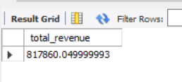

1. Average Order Value –

select SUM(total_price)/count(distinct order_id) AS Avg_order_value from pizza_sales;

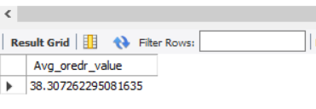

C) Total Pizza Sold –

select SUM(quantity) AS Total_pizza_sold from pizza_sales;

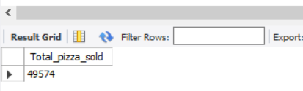

D) Average Pizza per Order –

select sum(quantity)/count(distinct order_id) AS Average_pizza_per_order from pizza_sales;

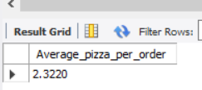

E) Total Order –

select count(distinct order_id) as total_order from pizza_sales;

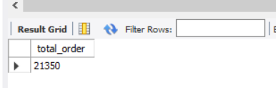

Chart Requirement-

1. Daily Trend of order-

SELECT DAYNAME(STR_TO_DATE(order_date, '%d-%m-%Y')) AS day_of_week, count(distinct order_id) as total_order

FROM pizza_sales

group by DAYNAME (STR_TO_DATE (order_date, '%d-%m-%Y'))

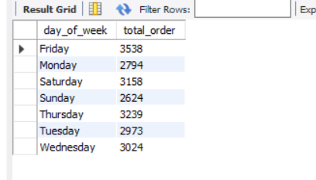

1. Monthly Trend of order-

SELECT monthname(STR_TO_DATE(order_date, '%d-%m-%Y')) AS Month, count(distinct order_id) as total_order

FROM pizza_sales

group by monthname(STR_TO_DATE(order_date, '%d-%m-%Y'))

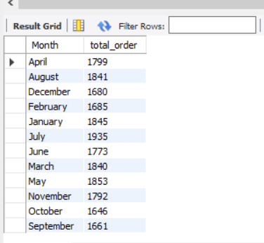

1. Percentage of Sales by Pizza category-

select pizza_category, cast(sum(total_price) as decimal(10,2)) as total_sale, cast((sum(total_price)*100)/(select sum(total_price) from pizza_sales ) as decimal(10,2)) as pct

from pizza_sales

group by pizza_category;

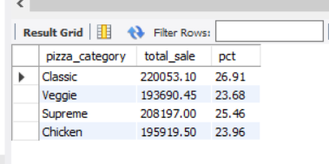

1. Percentage of Sales by Pizza size –

select pizza_size, cast(sum(total_price) as decimal(10,2)) as total_sale, cast((sum(total_price)*100)/(select sum(total_price) from pizza_sales ) as decimal(10,2)) as pizza_size

from pizza_sales

group by pizza_size;

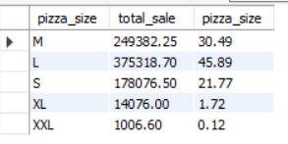

1. Top 5 pizza by Revenue

select pizza_name, sum(total_price) as revenue from pizza_sales

group by pizza_name

order by revenue DESC

limit 5

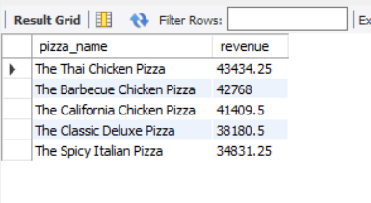

1. Bottom 5 pizza by Revenue

select pizza_name, sum(total_price) as revenue from pizza_sales

group by pizza_name

order by revenue ASC

limit 5

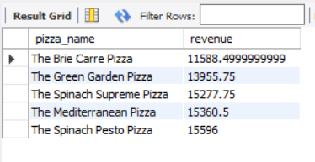

1. Top 5 pizza by number of quantity-

select pizza_name, sum(quantity) as total_quantity from pizza_sales

group by pizza_name

order by total_quantity desc

limit 5

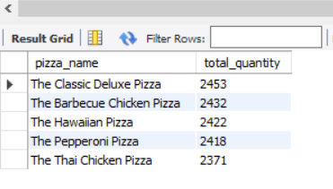

1. Worst 5 pizza by number of quantity-

select pizza_name, sum(quantity) as total_quantity from pizza_sales

group by pizza_name

order by total_quantity

limit 5

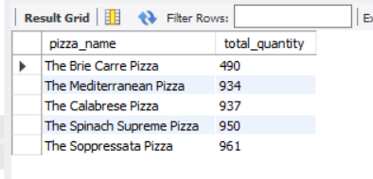

1. Top 5 Pizza in terms of no of order-

select pizza_name, count(distinct order_id) as total_order from pizza_sales

group by pizza_name

order by total_order desc

limit 5

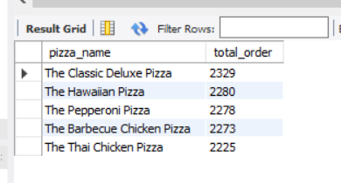

1. Worst 5 pizza in terms of no Order-

select pizza_name, count(distinct order_id) as total_order from pizza_sales

group by pizza_name

order by total_order

limit 5

